1

Measure the width of a table 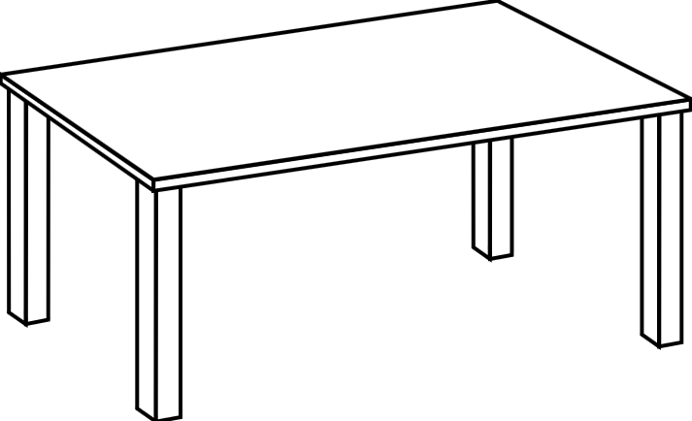

using paperclips



2

Measure the width of the SMART board

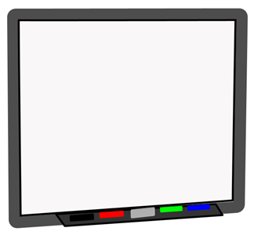

using cube links



3

Measure the length of the class line (marked by masking tape)



using chairs

[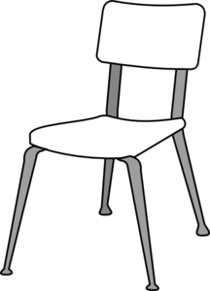](javascript:edit(229786))

4

Measure the height of the tallest student in your group

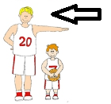

using pencil boxes

[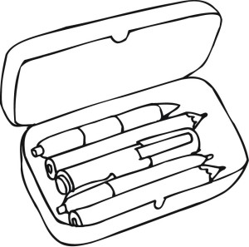](http://coloringhub.com/wp-content/uploads/2014/01/Box-coloring-pages-9.jpg)

5

Measure the length of the classroom

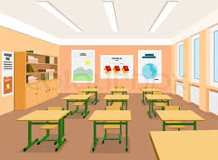

using the shortest student in your group

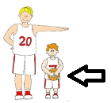

6

Measure the width of the teacher’s desk

[](http://www.google.ca/url?sa=i&source=images&cd=&cad=rja&uact=8&docid=7Rs14oS6C0lWCM&tbnid=XjrbUlu6HFvDiM&ved=0CAgQjRw&url=http%3A%2F%2Fwww.mycutegraphics.com%2Fgraphics%2Fteacher%2Fteachers-desk.html&ei=KXJMU7_3Eeab2wX_2IGgDA&psig=AFQjCNEt68cQYb7CaHlBr-RSXUG9thrNdA&ust=1397605289361123)

using pencils

[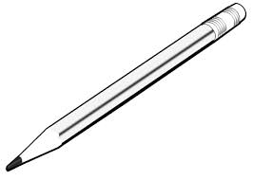](http://www.google.ca/url?sa=i&rct=j&q=&esrc=s&frm=1&source=images&cd=&cad=rja&uact=8&docid=cFXSlW2L1MAaiM&tbnid=keUnbBkRj5whBM:&ved=0CAUQjRw&url=http%3A%2F%2Fwww.clipartbest.com%2Fpencil-pictures&ei=zHFMU4rQN-io2wXwlIHIAg&bvm=bv.64542518,d.b2I&psig=AFQjCNGBLsdtgAMx6Z7l8F5iXTW17jk0qQ&ust=1397605174582788)

7

Measure the width of the door

[https://encrypted-tbn3.gstatic.com/images?q=tbn:ANd9GcTRIJ6nLxxR4dKb0WXWzw4SDnoGiNb73KE-idEOIl4JmbeM5uaX0onMl6k](http://www.google.ca/url?sa=i&rct=j&q=&esrc=s&frm=1&source=images&cd=&cad=rja&uact=8&ved=0CAQQjRw&url=http%3A%2F%2Fsweetclipart.com%2Fsimple-door-line-art-1076&ei=vXNMU9e0B8nW2gWbqIGQDQ&bvm=bv.64542518,d.b2I&psig=AFQjCNExh8qRL8RSCkWoONNlbb3V0jJuTg&ust=1397605693170102)

using coloured tiles

[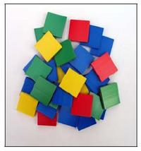](http://www.google.ca/url?sa=i&rct=j&q=&esrc=s&frm=1&source=images&cd=&cad=rja&uact=8&docid=YyO8xDRmVCm-qM&tbnid=U8Lhf9gbwRaqsM:&ved=0CAUQjRw&url=http%3A%2F%2Fmath-on-the-move.wikispaces.com%2FManipulatives%2BMoving%2BMath&ei=53JMU82RHITS2QW7voGYBA&bvm=bv.64542518,d.b2I&psig=AFQjCNG2yy-o5kL8tlwYjNElONx8avhpRQ&ust=1397605362625721)