Graphing Assessment
Name: ________________________ Date: _________________

1. Use the data from the tally chart to make a pictograph.
Pet | Tally | Number
Dog
Cat
Hamster
Bird

15
14
13
12
11
10
9
8
7
6
5
4
3
2
1

Write two things you know about the graph.

2. Use the pictograph to answer the questions about the results.

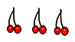
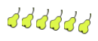

How many students chose pears? ____________
How many students chose bananas? ___________
Circle the fruit the students chose the most.

Circle the fruit students chose the least.

How many people voted? ____________

3. Pretend you were making a pictograph. What question will you ask?

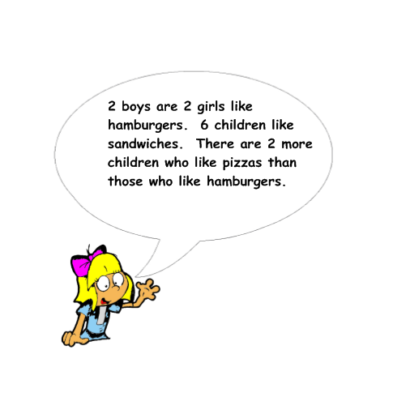

4. Read what the girl says. Make a pictograph.

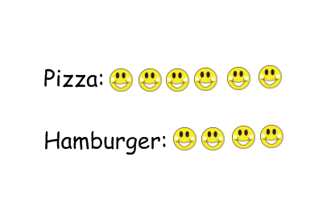
5.

Just as many kids like pizza as burgers. True or false? Explain.

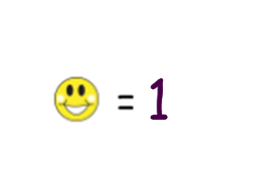

If each kids, how many kids were surveyed? ______________

