Play Online Games
Open Internet Explorer.

Type http://ivsgrade2.weebly.com

Click on Links for Students

Scroll down to Shape & Space
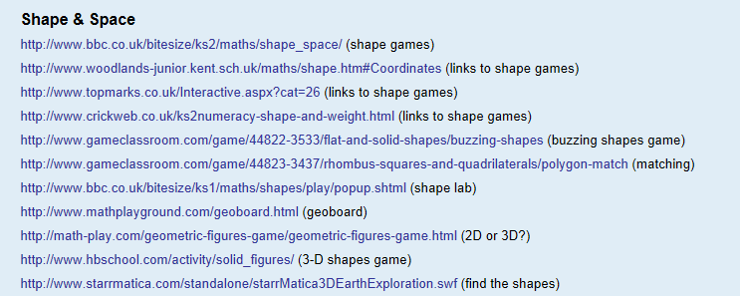
Click on any game in the list to play.

