Centre # 1 – Cube Link Bar Graphs

What you need:

- Cube links
- Bar Graph
- Title and Labels
- Numbers
- Data

Use this data to make a bar graph:

Favourite Pizza Toppings
Pepperoni – 8
Cheese – 5
Bacon – 9
Mushrooms – 3

_____________________________________________________
Detach this part and cut out each item before the centre:

Favourite Pizza Toppings Mushrooms

Pepperoni Cheese Bacon

Number of Students Toppings

1 2 3 4 5 6 7 8 9 10

Bar Graph

Centre # 2 – Animals Pictograph

What you need:

- Animal Counters
- Pictograph
- Title and Labels
- Data

Use this data to make a pictograph

Animals at the Farm
Cows – 4
Chickens – 6
Ducks – 3
Pigs – 2

_____________________________________________________
Detach this part and cut out each item before the centre:

Animals at the Farm

Number of Animals Animals

Cows Chickens Ducks Pigs

Pictograph

Centre #3 – Make a Bar Graph

What you need:

- Bar graph sheet
- Data

Use this data to make a bar graph:

Number of Siblings

Zero – 4
One – 9
Two – 7
Three – 2

Don’t forget to write a title, numbers, and labels on your bar graph. Here is an example:
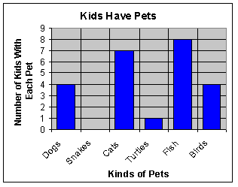
Centre #4 – SMART Board Graphs

You will make graphs on the SMART board.

You can make graphs on pages 6, 7, and 8.

Don’t forget to take turns!

Groups
Group 1 | Group 2
Group 3 | Group 4

