Name: _____________________________ Date: ____________________

Nonstandard Units of Measurement

The table is _______________ paperclips long.
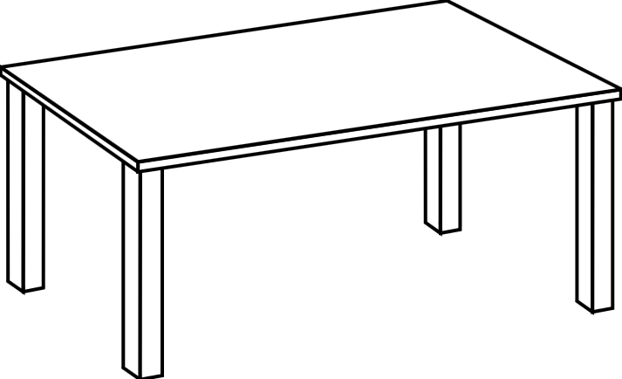

The SMART board is _______________ cube links long.

The class line-up is _________________ chairs long.
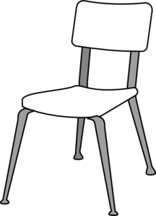

The tallest student in the group is ________________ pencil boxes long.
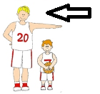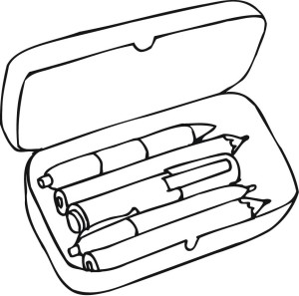
The classroom is ______________ of the group’s shortest students long.
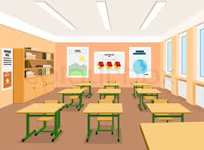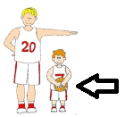

The teacher’s desk is ________________ pencils long.
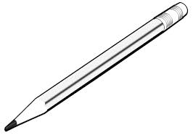

The door is ___________________ coloured tiles long.
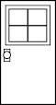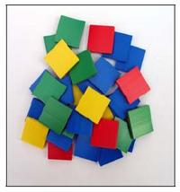

The ________________________ is ___________ _________________ long.

